Year 2 Unit 2: Add and subtract 2-digit numbers (2weeks)

Key Objectives: | Representations:
Using known facts within ten to derive facts within 20  - Use number bonds within 20 in addition  - Use number bonds within 20 in subtraction  Using the Big Picture as real-life stimuli, pupils engage in mathematical thinking by deriving addition and subtraction equations within 20 using their knowledge of number bonds within 10. Encourage discussion around similarities and differences within part-whole relationships; Dienes on part whole models emphasise the pattern in known facts and derived facts. If you are unfamiliar with the part-whole model, use the videos to become confident with coordinating your actions and words.. | 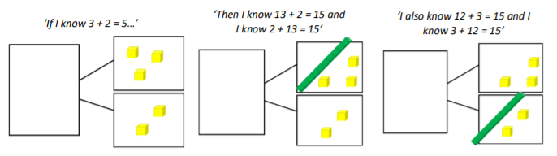
Adding and subtracting tens or ones
- Add and subtract ones from a 2-digit number
- Add and subtract multiples of ten
- Add and subtract tens from a 2-digit number

Pupils use their known facts within ten to now extend to deriving facts within 100. Pupils continue to demonstrate mental calculations using Dienes on a part-whole model. When calculating with multiples of ten, emphasise the language structure related to unitising ‘If I know three ones and four ones is equal to seven ones, then three tens and four tens is equal to seven tens’– to support pupils’ fluency.
Adding and subtracting tens and ones  - Add two 2-digit numbers  - Subtract 2-digit numbers  - Add and subtract 2-digit numbers  Pupils combine their knowledge of adding or subtracting only ones or only tens and now calculate with two 2-digit numbers. Making connections between different mental strategies is key here – partitioning both numbers to add or subtract, compared to partitioning only the number to be added or subtracted. Dienes, part-whole models and number lines allow pupils to demonstrate their mental calculations. This supports discussion about pupils’ different methods. | 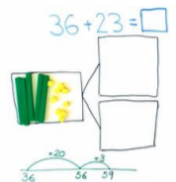
Calculating with three numbers  - Add three 1-digit numbers  Pupils apply their number sense to decide the most efficient order to add three 1-digit numbers. Commutativity can be emphasised here – it doesn’t matter which order the numbers are added, the whole remains the same. Provide opportunities for pupils to share their calculation method, justifying their choice. Suggested strategies include number bonds to 10 or 20, doubles and near doubles. | 