Year 4 Unit 7: Time (1week)

Key Objectives: | Representations:
Understanding and using clocks  - Read analogue and digital 12-hour clocks  - Read and understand 24-hour time  Pupils read and convert between digital and analogue as well as 12-hour and 24-hour format. Through this, they develop an understanding of the relationship between the different formats as well as how these are said. These lessons include lots of opportunities to explore the language structures used to say the time. Encourage the use of nearly, almost, just before, approximately and exactly to develop flexibility with telling the time. | 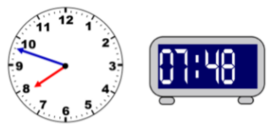
Understanding relationships between units of time  - Convert hours, minutes and seconds  - Convert years and months, and weeks and days  Pupils work with different units of time, developing a sense of their duration by exploring relationships between them. Converting between units of time provides opportunities to apply number and calculation work from the autumn term. Number lines are used to visualise strategies and relationships. | 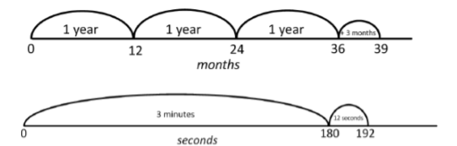
Solving problems involving time  - Solve problems using knowledge and understanding of time  Pupils use knowledge from the previous lessons to solve different time problems based on events at an airport. This lesson is an opportunity to tackle misconceptions and consider efficient ways of calculating time durations. | 

