Year 5 Unit 6: Fractions & Decimals (3weeks)

Key Objectives: | Representations:
Interpreting fractions in different ways  - Recognise different interpretations of fractions  - Represent fractions  Fractions are complex and can be interpreted in different ways; use the first lesson as an opportunity to explore various interpretations and assess pupils’ understanding. In lesson two, Cuisenaire rods provide further opportunity to explore, reason and deepen pupils’ understanding of fractions. | 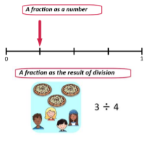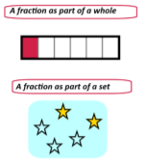
Understanding equivalent fractions  - Identify, name and write equivalent fractions  - Equivalent tenths and hundredths  - Compare and order fractions  Pupils explore equivalent fractions including equivalents for tenths and hundredths. Experiences with equivalent fractions should go beyond multiplying the numerator and denominator by the same value. The focus should be on identifying different relationships between and within fractions, noticing patterns and allowing pupils to make connections to multiplication and division. | 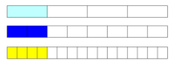  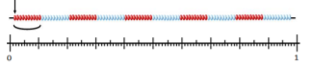
Connecting fractions and decimals  - Read and write fractions as decimals.  - Relate thousandths to tenths and hundredths  - Compare and order decimals and fractions  Year 5 is the first time pupils will explore thousandths. Dienes blocks are assigned new values (see above) and are used to represent and connect fractions and decimals. Pupils explore the relationship between thousandths, tenths and hundredths. Draw attention to connections between decimal place value and whole number place value. Pupils should then have the opportunity to compare both decimals and fractions by placing them on a number line, explaining their choices and generating statements of inequality. | 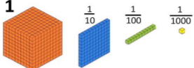
Understanding mixed numbers and improper fractions  - Recognise improper fractions and mixed numbers  So far the focus has been on fractions that are less than one. This lesson reviews learning from Year 4, providing opportunities to explore mixed numbers and improper fractions using Cuisenaire. Connections should be made to decimal numbers greater than 1. Inequality statements are explored and pupils should be encouraged to use Cuisenaire to support an explanation of how they know they are correct. | 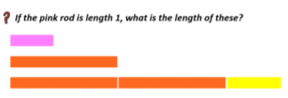
Exploring numbers with up to three decimal places  - Read, write and order numbers with up to three decimal places  - Round decimals  Pupils explore the value of each digit within decimal numbers, using place value counters. Connections should be made to whole number place value. Number lines are the chosen representation because it supports pupils in understanding relationships between numbers. Again, connections should be made to previous learning of rounding whole numbers. | 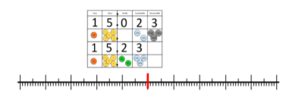
Solving problems with fractions  - Solve problems involving fractions and division  Pupils explore division problems in context, connecting short division with place value counters to fractions. Pupils recognise that remainders can be written as a decimal and are encouraged to record answers in more than one way to show their understanding. | 